Ecovi Serial-communication Protocol (ESP)

Installation and User Manual

Wuxi Ecovi Technology Co., Ltd

Copyright 2011

1. Installation 3
1.1 Decompression File 3
1.2 Install Software 3
2. Operation 4
2.1 ESP basic functions 4
2.2 User Interface 4
2.3 SerialPort Configuration 6
2.4 Washing machine [Debug] 7
3. Examples of device connection 9
4. Recommendation for protocol of use 9
4.1 DD washer procedures 10
4.2 ESP protocol 10

- Installation

Decompression File
- In order to improve the speed of installation, for computers that have never installed .NET Framework, it is recommended to unzip ESP.rar to any location where you like.

Install Software
- Double-click “setup.exe” in the folder as shown below.
- 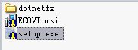
- Click “Next” and choose a location to install the files. The default location, “C:\Program Files\ECOVI\ESP\”, is recommended.
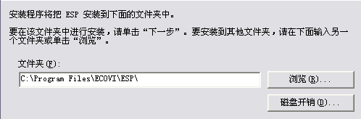
- Then click “Next”. Computers without .NET Framework need to spend some time to extract the necessary files from ESP. Installing time is about 1 minute.
- Desktop will appear an icon after the completion of installing, double-clicking the icon will lead to running ESP. The aspect of the icon is shown below.

- Operation
- ESP basic functions
- Integration of serial port assistant and communication protocol. Be able to send and receive instructions, and set up configuration of serial port.
- Be able to send instructions relevant to protocol by opening the configuration file, and modify communication protocol by modifying the configuration file as well.
- Simulation of washing process of washing machine and setting its parameters.
- Build-in counter and timer. You can switch it on if needed.
- Has calibration and operation function
- User Interface
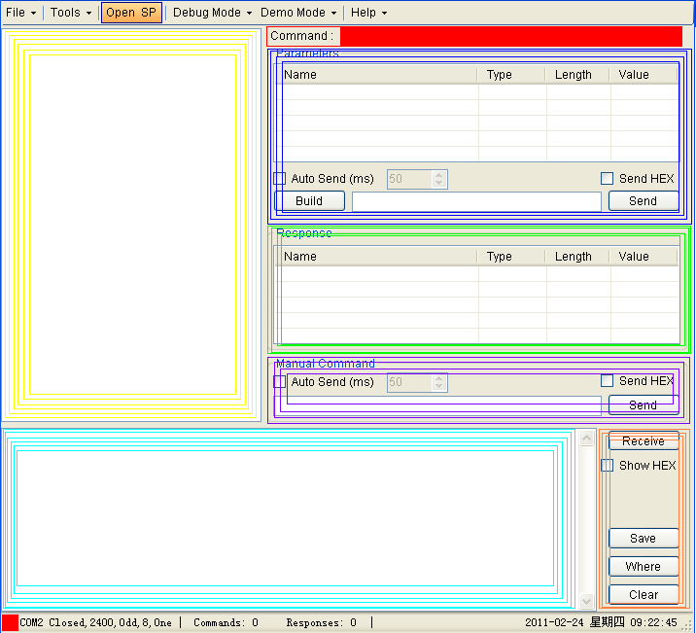
  Area | Description
  Head line | Menu bar
  Yellow area | List of instructions
  Red area | Current selected instruction
  Blue area | Selected instruction’s parameters, generation, send, auto-send, switching of HEX and ASCII.
  Green area | Return parameters of selected instruction.
  Purple area | Input data’s send, auto-send, switching of HEX and ASCII.
  Cyan area | Received data.
  Brown area | Received data’s HEX and ASCII switching, save data, open saved file, clear received data.
  Bottom line | Current serial port status, configuration, sum of received and sent instructions, current date and time.

- Menu

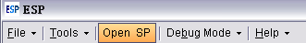

From left to right, the Menu bar includes “File”, “Tools”, ”Open SP”, “Debug Mode”, and “Help”.

- “File”

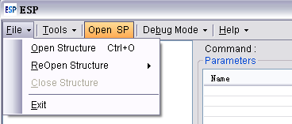

The “file” menu includes “Open Structure”, “ReOpen Structure”, “Close Structure” and “Exit” from top to bottom
“Open Structure”: Open a configuration file.
“ReOpen Structure”: Re-open a configuration file.
“Close Structure”: Close the configuration file.

- “Tools”

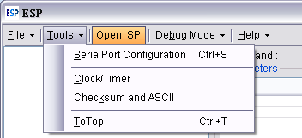

It includes “SerialPort Configuration”, “Clock/Timer”, “Checksum and ASCII” and “ToTOp”.
“SerialPort Configuration”: see Claus 2.3 for details.
“Clock/Timer”:
“Checksum and ASCII”:
“ToTOp”:

- “Debug Mode”

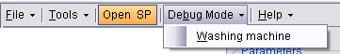

Currently it only includes “Washing machine”.
The Debug Mode of “Washing machine” is described in Claus 2.4 in detail.

- “Help”

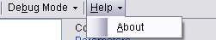

It includes “About”. Here you can find help information about using this tool software.
- SerialPort Configuration
The window of serialport configuration is shown below.
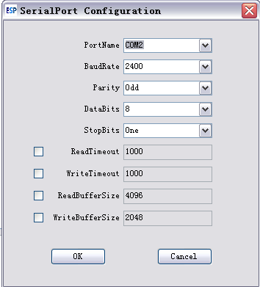
It is recommended to set “ReadTimeOut” and “Write TimeOut” to 1000 to prevent program feign death.

- Washing machine [Debug]
The window of Washing machine [Debug] is shown below.
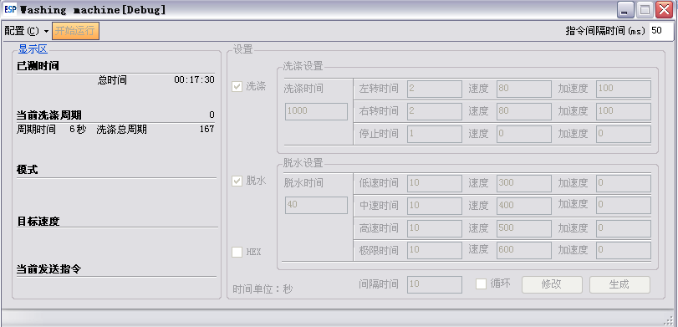

- Configuration of Washing machine [Debug]

- Click Menu “Configuration“, choose configuration file. The below figure shows the configuration of ESP protocol for washing machine. The left side is “Display“ area, and the right side is “Setting“ area.
Configuration
Start to run

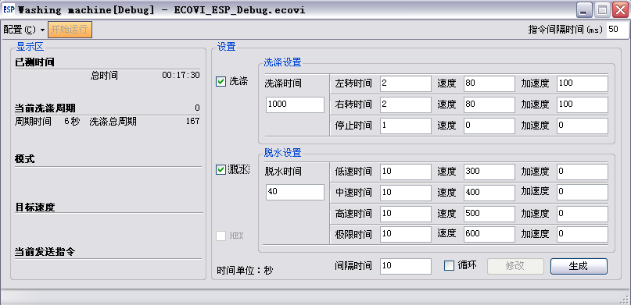
running time
current washing cycle
mode
target speed
current instruction sent
Display area
Setting area
Wash
Time unit: S
Setting of wash cycle
Setting of spin cycle
interval time
repeat
change
generate

In “Display“ area,
it shows:
- the running time and total test time
- the current washing cycle, cycle time, and total washing cycle time
- the mode
- the target speed
- the current instruction sent
In “Setting“ area
Firstly on left side you can select “Wash“, “Spin“, or “HEX“. Then you can setting the related parameters.
The upper right is the “Setting of wash cycle“ area, where you can set total wash cycle time (s) and:
- CCW running time (s), speed (rpm), and acceleration (rpm/s)
- CW running time (s), speed (rpm), and acceleration (rpm/s)
- stop time (s), speed (rpm), and acceleration (rpm/s)
The lower right is the “Setting of spin cycle“ area, where you can set total spin cycle time (s) and:
- low speed time (s), speed (rpm), and acceleration (rpm/s)
- mid speed time (s), speed (rpm), and acceleration (rpm/s)
- high speed time (s), speed (rpm), and acceleration (rpm/s)
- fastest speed time (s), speed (rpm), and acceleration (rpm/s)
On bottom you can select “Repeat“, and set the interval time (s).
- Run of Washing machine [Debug]
- Before finishing setting parameters, click “change” if modification is needed. Then click “Generate”. (“change” and “Generate” are on bottom right).
- Click “Start to run“ from the Menu bar, the Debug will communicate with the MCU (Motor Control Unit) and control the motor to run by itself according to the setings.
- Stop of Washing machine [Debug]
- Click “Stop“ from the Menu bar, then click “OK”, the Debug will stop the motor running. In case it does not work, please click “ Start to run“ then click “Stop” again.
- Examples of device connection
Firstly install the tool software ESP in a PC. Through a USB-to-Serial port cable, the PC connects to the communication box, then connects to the MCU via another specific cable, refer to figure below.

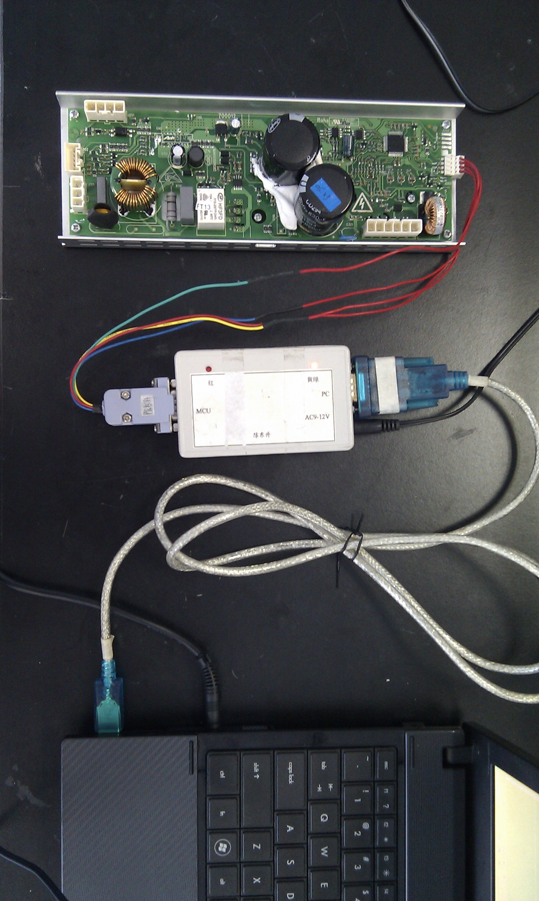

- Recommendation for protocol of use
You can choose Wash, Spin, Repeat in the window of Washing machine [Debug].
If choosed only the Wash, the PC will repeatedly send instructions in order of stop, turn left, stop, turn right;
If choosed only the Spin, the PC will send instructions in order of low speed, mid-speed, high speed, and fastest speed;
If choosed the Wash and Spin, the PC will send instructions of Wash then Spin;
If choosed Repeat, the PC will send instructions repeatedly after the interval time.

4.1 DD washer procedures
- Click File->Open Structure in main interface, then select DD.xml to open.
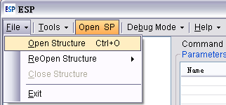
DD.xml includes the configuration of DD washer project, the baud rate is set to 2400bps as default and odd check is loaded.
- Debug Mode->Washing machine simulation procedures
- Configure->Open Configure, then choose DD Debug.ecovi, time unit is set to second, and the acceleration is free to modify.
- Click Generate->Start to run. (Menu “Start to run“ switches to “Stop“)
If you want to stop running the washer procedures, just click Stop in the menu.
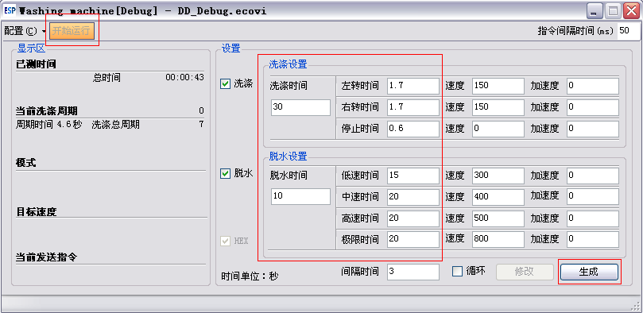

4.2 ESP protocol
- Click File->Open Structure in main interface, and choose ECOVI_ESP.xml to load the ESP protocol.
ECOVI_ESP.xml does not contain configurations of projects.
- Click Tools -> Serial Port Configuration to set the configuration.
The Baud Rate of DD project and Check is set to 2400bps and odd respectively.
The Baud Rate and Check of Viano_A1 is 2400 and None.
The Baud Rate and Check of Viano_A2 is 2400 and None.
The Baud Rate and Check of Viano_W1 is 9600 and None.
- Click Debug Mode->Washing machine
- Click Configuration->Open configuration, and choose ECOVI_ESP Debug.ecovi, time unit is set to second; the acceleration can be modified.
- Click Generate->Start to run. (Menu “Start to run“ switches to “Stop“)
If you want to stop running the washer procedures, just click Stop in the menu.

